4. UML Class Diagram
The classes below were derived from the user stories in Section 2 and from the actors and use cases in Section 3. Method names reuse the Function column of the backlog so that the three models remain consistent and the design can be implemented directly in Part 2. The subsections follow the five criteria of the marking scheme: classes, fields, methods, relationships and multiplicity.

4.1 The class diagram
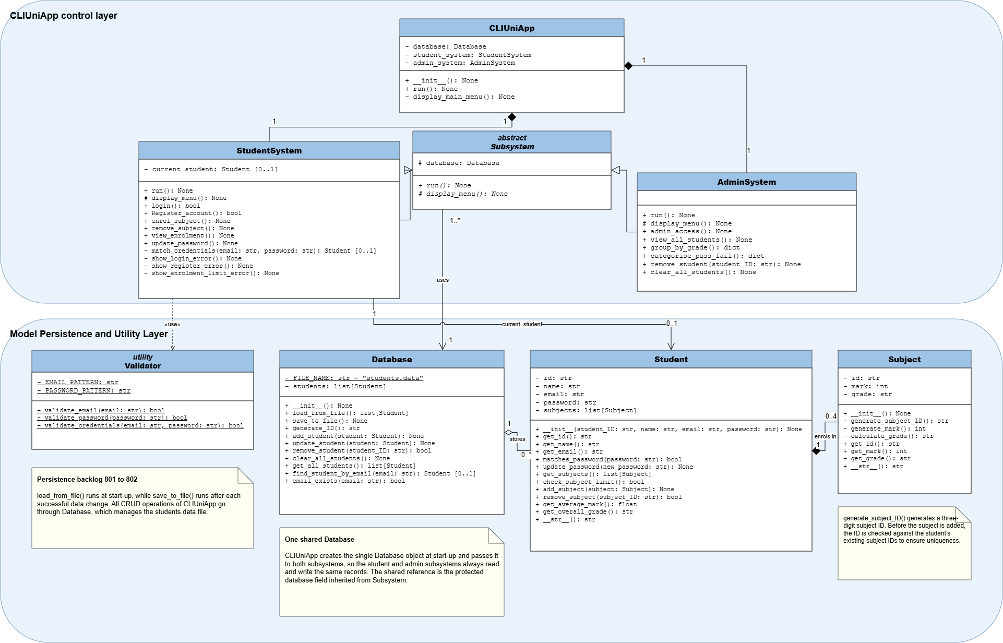
Figure 4.1 UML class diagram of CLIUniApp

4.2 Classes
Class | Layer | Responsibility
Student | Model | A registered student. Owns the enrolment list, checks the four-subject limit, verifies its own password and derives its average mark and overall grade.
Subject | Model | One enrolled subject. Generates its own three-digit id and random mark and derives the grade, because the brief states that the student does not choose a subject.
Database | Persistence | The only class that reads and writes students.data. It also generates the six-digit student id, because uniqueness can only be guaranteed by the class that holds every record.
Validator | Utility | Applies the email and password patterns defined in the brief. It holds no instance state, so all of its members are static and it is never instantiated.
CLIUniApp | Control | Entry point of the application. Creates the single Database object and the two subsystems and shows the main menu.
Subsystem (abstract) | Control | Common structure of a menu-driven subsystem: the shared database reference and the two operations every subsystem must supply.
StudentSystem | Control | The student subsystem: log in, register an account, enrol in a subject, remove a subject, view the enrolment list and update the password.
AdminSystem | Control | The admin subsystem: access without registering, view all students, group them by grade, categorise them as PASS or FAIL, remove one student and clear the file.

4.3 Fields and visibility
Class | Fields | Vis. | Reason for the visibility
Student | id, name, email, password, subjects | - | Set at registration and afterwards changed only through update_password(), add_subject() and remove_subject().
Subject | id, mark, grade | - | All three are produced by the object itself and must never be assigned from outside.
Database | students | - | The in-memory record list is reachable only through the CRUD methods.
Database | FILE_NAME | - static | The file name belongs to the class rather than to an instance and never changes, so it is underlined in the diagram.
Validator | EMAIL_PATTERN, PASSWORD_PATTERN | - static | The two patterns are fixed rules of the class; Validator holds no instance state.
Subsystem | database | # | Protected so that StudentSystem and AdminSystem inherit the same Database reference.
StudentSystem | current_student : Student [0..1] | - | Empty before a successful login and holding exactly one student afterwards, which is why the association is typed 0..1.
CLIUniApp | database, student_system, admin_system | - | Objects the application owns; not part of any interface it offers.
AdminSystem | (none) | — | An administrator is not a stored record, so the subsystem keeps no state of its own beyond the inherited database reference.

4.4 Methods
Methods are named after the Function column of Section 2, and every function named there appears in the diagram under the same name. A method that returns a value is typed with what it returns; a method that performs an action and returns nothing is typed None. Public methods form the interface a class offers to others, private methods only support an operation of the same class, and the two abstract operations declared by Subsystem are implemented by both subsystems.
Kind | Examples | Returns | Vis.
Constructor | CLIUniApp.__init__(), Database.__init__(), Student.__init__(student_ID, name, email, password), Subject.__init__() | None | +
Abstract operation | run(), display_menu() | None | + / # (declared by Subsystem, implemented by both subsystems; shown in italics)
Student interface operation | login(), Register_account(), enrol_subject(), remove_subject(), view_enrolment(), update_password() | bool / None | +
Admin interface operation | admin_access(), view_all_students(), group_by_grade(), categorise_pass_fail(), remove_student(student_ID), clear_all_students() | None / dict | +
Validation | validate_email(email), validate_password(password), validate_credentials(email, password) | bool | + static
Credential check | match_credentials(email, password), matches_password(password) | Student [0..1] / bool | - / + (match_credentials is a private helper of login(); matches_password lets Student confirm a password without exposing it)
Business rule | check_subject_limit(), add_subject(subject), remove_subject(subject_ID), get_average_mark(), get_overall_grade() | bool / None / bool / float / str | +
Generator | generate_ID() on Database; generate_subject_ID(), generate_mark(), calculate_grade() on Subject | str / str / int / str | + on Database - on Subject (a subject generates and grades itself internally)
Persistence | load_from_file(), save_to_file(), add_student(student), update_student(student), remove_student(student_ID), clear_all_students(), get_all_students(), find_student_by_email(email), email_exists(email) | list[Student] / None / bool / Student [0..1] | +
Accessor | get_id(), get_name(), get_email(), get_subjects(), get_mark(), get_grade() | field type | +
Error message | show_login_error(), show_register_error(), show_enrolment_limit_error() | None | - (triggered internally, matching the <<extend>> use cases of Section 3)

4.5 Relationships
Relationship | Type | Justification
Student — Subject | Composition | A Subject is created by the act of enrolling and has no meaning once the student record is deleted, so the two lifetimes are bound together and the multiplicity at the composite end is exactly one.
Database — Student | Aggregation | Database groups the student records for the duration of a session, but they live in students.data and outlive any Database object, so the part is not owned by the whole.
CLIUniApp — StudentSystem | Composition | The application creates the student subsystem at start-up, and it is destroyed with the application.
CLIUniApp — Admi System | Composition | The same for the admin subsystem, which together give the two interactive subsystems the brief requires.
StudentSystem, AdminSystem — Subsystem | Generalization | Both are subsystems: they inherit the protected database field and implement run() and display_menu(). Neither adds a field the other lacks, so the 100% rule holds.
Subsystem —> Database | Association (navigable) | Both subsystems work through the same Database object, which is what keeps every CRUD operation on the single students.data file.
StudentSystem —> Student | Association, role current_student | The subsystem holds the student it is acting for, from a successful login until the return to the main menu.
StudentSystem --> Validator | Dependency <<use>> | Validator is never instantiated, so the calling class holds no object reference; the weaker dependency is correct rather than an association.

4.6 Multiplicity
Relationship | Multiplicity | Reason
Student — Subject | 1 to 0..4 | A subject belongs to exactly one student. A student holds none at first and at most four, so the multiplicity states the four-subject limit in the model itself.
Database — Student | 1 to 0..* | students.data may be empty or hold any number of registered students.
CLIUniApp — StudentSystem | 1 to 1 | The application owns exactly one student subsystem.
CLIUniApp — AdminSystem | 1 to 1 | The application owns exactly one admin subsystem.
Subsystem — Database | 1..* to 1 | One Database object is shared by the subsystems, and each subsystem knows exactly one Database.
StudentSystem — Student | 1 to 0..1 | No student object is held before a login succeeds, and exactly one afterwards.

